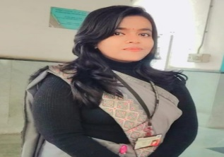

**PROFILE SUMMARY**

# **SKILLS**

**Jaya Kumari**

SCHOOL TEACHER

* Teaching Planning
* Learning Creativity
* Individual Approach

I am an English & History teacher. I teach students from

J.S. Public School. I also have experience working with children with children with special needs. I like to use

Interactive materials in my work to make learning interesting

**EDUCATIONAL QUALIFICATION**

* 10th Passed from UP Board in 2015.
* 12th Passed from UP Board in 2017.
* BA. B.ED Passed from MIMT (CCSU Meerut) in 2024.

**EXPERIENCE**

* 1-Years worked experience in J.S. Public School kasna Gr. Noida as a English & History

Teacher.

**STRENGTH & HOBBIES**

* Honesty, Hardworking
* Team work, Punctuality

**PERSONAL DETAILS**

Father Name Sri Pramod Kumar

Date of Birth 09/07/2000

Gender Female

Marital Status Unmarried

Nationality Indian

Language English & Hindi

DECLARATION

I hereby declare that all the information furnished above is true and correct to the best of my Knowledge and brief.

Email:-jayakeshri14@gmail.com

Mobile:-7678360203

Address:- MU-2 Gr. Noida UP – 201310